

Behaviour Policy

This is a Trust wide adopted policy – individual schools will populate the policy with specific details - please visit the individual school website.

Review Summary
Approved By: | Trust Board
Approval Date: | July 2025
Next Review Date: | Bi-Annual

Date policy approved by Trustees:
Date policy becomes effective: September 2025
Review date: (Bi-Annual)
Person responsible for Implementation and Monitoring: Headteacher

- Policy Statement

It is the aim of all schools within Truro and Penwith Academy Trust (TPAT) that every pupil has the opportunity to enjoy their learning, experience belonging success, and realise their full potential. Our Behaviour Policy reflects these aims and recognise that the behaviour of children in our schools has a significant effect on the motivation, social development and attainment of all pupils.

TPAT schools are committed to our shared core purpose, which is at the heart of all we do. This core purpose is to improve the life chances for all children and young people in our schools. Our school’s mission/ core values are aligned with that of the Trust:

We use The Nanpean Way to support these values.
The Nanpean Way
The Nanpean Way defines the high standard of behaviour that we expect from all pupils.
‘The Way’ will be displayed in all classrooms and communal areas. Pupils are expected to behave in line with these rules at all times, We reserve the right to take action where the behaviour of a pupil out of school hours may have a negative impact on the reputation of the school.
‘The Way’ clearly defines the high standard of behaviour that we expect in school. It is referred to frequently and should encourage the pupils to be positive in all they do and should help to create a happy environment for pupils to work in. It is the responsibility of pupils to make good choices at all times with the adults and pupils in school. ‘The Way’. E.G – Ready, Respectful, Safe
Be Ready
- We are always prepared and ready to learn.
- We make the most of our learning time.
- We wear our uniform with pride. We make sure we look smart every day.
- We can be ready to learn with anyone.
- We arrive at school on time each day.
Be Respectful
- We care for everyone and everything at our school.
- We use good manners at all times (Nanpean Manners)

- We treat every member of our community and their beliefs, with respect.
- We empathise with others.
- We follow instructions with thought and care.
Be Safe
- We walk safely and calmly on the left at all times.
- We say kind words; we show kind actions.
- We are responsible for our own actions and their impact on others.

Our school values help give our school and our pupils a strong sense of identity. Our school values echo our beliefs in the importance of doing the right thing, working hard together and being resilient in everything we do. Our pupils are given a strong moral compass. They value the differences in themselves and in others. They understand the importance of community cohesion and making a positive contribution to the community in which we live and to our wider global community. Our whole staff team, parents and pupils are involved in promoting our values and recognising where others are ‘living the values’.

This policy should be read in conjunction with existing school policies including (but not limited to) the following policies:
- Safeguarding and Child Protection
- Special Educational Needs and Disability
- Exclusions and Suspensions
- Anti-Bullying Policy
- IT Acceptable Use

- Aims

- To foster in our pupils a sense of belonging within our school and with our Trust values.
- To make the most of opportunities to reward and celebrate positive behaviour and contribution to our schools.
- To reinforce our school culture of respect: respect for others, respect for our environment and respect for the views and beliefs of others.
- To ensure that standards, rules, rewards and consequences are applied and used consistently and fairly.
- To clarify the roles and responsibilities of all parties with respect to behaviour.
- To encourage pupils to be self-disciplined and responsible, and to understand the consequences of their actions on themselves and others.

- Introduction
Our Behaviour Policy applies in school, when children are travelling to and from school, when children are in uniform, and on any educational trips or visits. Our policy also applies to pupil’s conduct out of school when witnessed by a member of staff or reported by a member of the public. Where appropriate, the school will work with external partners, including social care and the police in the implementation of our Behaviour Policy. In line with our school values and ethos, we are committed to:
● Protecting the right to learn, the right to teach and the right to feel safe and be safe
● Valuing all people as individuals
● Promoting equality and celebrating diversity and difference
● Listening and communicating clearly
● Encouraging openness, personal responsibility for own actions, and honesty
● Rejecting all forms of violence and aggression
● Rejecting all forms of sexual violence, abuse and harassment
● Rejecting all forms of bullying
● Actively promoting co-operation, collaboration and fairness
● Protecting and nurturing self-esteem, self-confidence and dignity

- Behaviour Standards

Our standards for behaviour form the foundations on which we build our respectful school community. We believe that pupils should adopt behaviour that supports their own learning and that of others. Poor behaviour and disruption to lessons prevent the learning of others, and may be intimidating, threatening and unsafe. Therefore, our standards are:
- That pupils arrive on time to school and lessons, ready to learn.
- That pupils consistently follow the school’s Uniform Policy and cooperate with the support offered by the school so that they are in the correct uniform and follow the school’s expectations for appearance.
- That pupils move around the school in a calm and orderly manner, following the school’s circulation plan including ‘one way systems’ and other instructions where these are in operation.
- That, at all times, pupils act in a manner which is polite and respectful towards other members of the school community and school visitors.
- That pupils follow instructions given by adults in a positive and cooperative way, in lessons, at social times, before and after school and in all school activities.
- That pupils always act in a way which upholds the core British Values of mutual respect, individual liberty, tolerance of difference cultures and religions, the rule of law, and democracy.
- That pupils behave in a way which enables their peers and themselves to achieve their full potential: in terms of their academic progress and their personal and social development.
- That pupils engage positively in dialogue and restorative practices, supported by school staff, to resolve personal issues and any disruption to their relationships with others.
- That pupils always act in a way which keeps themselves and others safe.
- That pupils report concerns or conduct which breaches these actions to a trusted adult in the school.

Specifically, pupils must not:
● Bring banned substances into school (see Appendix 1).
● Act in any way which puts at risk the safety of themselves or others in the school.
● Act in a way which disrupts their own learning, or the learning of others, or prevents a teacher or member of staff from carrying out their role.
● Discriminate against others on the grounds of protected characteristics: age, disability, sexual orientation, religion or belief, gender or gender re-assignment, race, religion or belief, pregnancy or maternity, marital status. Prejudiced behaviour and discrimination is unacceptable and not tolerated within our school.
● Threaten to, or act in any way which is physically aggressive or violent. All members of our school community are required to use non- violent resolution (dialogue and restorative practice) to resolve differences of opinion, relationships and conflict.
● Swear or use foul or abusive language, or language which is discriminatory or prejudiced.
● Act in any way which is illegal or which would constitute a criminal offence. In these circumstances, the school will work in partnership with Devon and Cornwall Police.

- Behaviour Curriculum

Positive behaviour underpins our school ethos and values and is demonstrated by pupils through their readiness to learn, feeling safe, feeling that they belong and showing respect for others. We teach pupils about our behaviour standards so that they understand our standards, what is required and why, and what is unacceptable. Our Behaviour Curriculum curriculum is explicitly taught during the first two weeks of the Autumn term. Pupils will learn the content of the curriculum so that they can recall the information and act upon it. At the beginning of every term the behaviour curriculum is revisited thoroughly and is reinforced throughout the year. Teachers consistently model these behaviours and ensure children have time to practise these regularly, particularly at the beginning of the year and when revisiting them termly. For example, lining up in different locations, moving during transitions and the expected behaviours during teaching and learning inputs.

When pupils join our school, we ensure that our standards, along with a summary of our behaviour policy are explained to them, and their parents. We include a summary of our behaviour standards in our Welcome Pack for families. Explaining our Behaviour Standards clearly to new students is an important part of our induction programme. Activities offered to pupils during our induction programme are selected to provide opportunities for them to understand our standards. Our Behaviour Policy is shared with parents annually, via email and is available on our website.

- Students with Special Educational Needs

In order to meet our legal duties to avoid substantial disadvantage to a disabled child, to use our best endeavours to meet the needs of children with SEND, and in line with children’s needs as set out within their Education, Health and Care Plans, our Behaviour Policy is adapted, as appropriate. Adaptations to provision for children with SEND are led by our SENDCO. All staff are required to make appropriate adaptations to support positive behaviour in response to pupils’ special educational needs.
Examples of adaptations to provision which are intended to support children to be able to achieve our standards include:
- Short, planned movement breaks for a child with SEND who finds it difficult to sit still for extended periods of time
- Adjusting seating plans to enable a child with visual or hearing impairment to sit in sight of the teacher.
- Adjusting uniform requirements for a child with sensory issues or who has severe eczema.
- Training for staff in understanding conditions such as autism.

The SENDCO will ensure staff understand students’ needs, as appropriate to the member of staff’s role within the school. The SENDCo will provide staff with relevant and appropriate information to be able to support pupils with SEND to engage successfully with the school’s expectations in a way which is aligned to their individual needs.

When considering a behaviour sanction for behaviour which does not meet the school’s standards, the school will take into account whether the child was able to understand the rule or instruction, whether the school was able to behave differently at the time because of their SEND, whether or not the child’s SEND would have had an impact on their behaviour. The school will consider whether any reasonable adjustments need to be made to the sanction or school response. At all times, the safety of the child, and others will take precedence. .

Where a child does not have an identified need, the school will consider whether an underlying need may be present and a factor. The school will make an informed decision, based on staff observation the views of the child and parents, and advice from other professionals. The SENDCo will support staff involved in reaching an informed decision and will regularly review children’s learning and behaviour records to determine whether there may be additional needs.

- Recognising and Celebrating Positive Behaviour and Contribution.

Our school values and celebrates the positive contribution, successes and achievements of all our pupils. Our approach to rewarding positive behaviour and contribution is detailed in Appendix 2.

- Managing Behaviour which does not Meet the School’s Standards
Our school has a fair and transparent procedure for managing behaviour which does meet our standards. Our procedure is followed consistently, supports our school ethos of inclusion and equity and is detailed in Appendix 3.
Following a sanction or consequence, the school will consider how to help pupils to understand how to improve their behaviour to meet the school’s standards. This may include, for example,
- A reintegration meeting following suspension
- Regular mentoring from an identified member of staff
- A behaviour support plan
- Specific intervention to address an identified need

- Suspensions and Permanent Exclusions

In line with the TPAT Exclusion Policy, the Headteacher may decide to suspend or permanently exclude a pupil for a serious breach or persistent breaches of the school’s Behaviour Policy where allowing a pupil to remain in school would seriously harm the education or welfare of the pupil or others. Further details are available in the Exclusion Policy.

- Safeguarding

Our School recognises that changes in a child’s behaviour may be an indicator that they are in need of help or protection. All our school staff are trained to consider whether a student’s behaviour may be linked to them suffering, or being at risk of suffering, significant harm. Where this may be the case, we follow our Safeguarding and Child Protection Policy, and consider whether pastoral support, an early help intervention and/or a referral to children’s social care is appropriate. Please refer to our Safeguarding and Child Protection Policy for more information.

11. Roles and responsibilities

The Local Monitoring Committee (LMC)
The Local Monitoring Committee is responsible for monitoring this Behaviour Policy, its
effectiveness and holding the Headteacher to account for its implementation.

The Headteacher (or member of staff with delegated responsibility)
The Headteacher is responsible for:
- Reviewing and approving this behaviour policy.
- Ensuring that the school environment encourages positive behaviour.
- Ensuring that staff have the knowledge and skills to deal effectively with poor behaviour.
- Monitoring how staff implement this policy to ensure rewards and sanctions are applied consistently to all groups of students.
- Ensuring that all staff understand the school’s behaviour standards and the importance of maintaining them.
- Providing new staff with an induction programme which includes understanding the school culture, ethos and values, and the rules and routines within the Behaviour Policy.
- Offering appropriate training in behaviour management, and the impact of special educational needs and disabilities (SEND) and mental health needs on behaviour, to any staff who require it, so they can fulfil their duties set out in this policy.

Staff
Staff are responsible for:
- Modelling respect towards of all members of the school community
- Supporting and caring for pupils
- Modelling the school’s values and standards in their own behaviour, leading by example
- Supporting the school’s ethos and values and promoting these to pupils
- Having high expectations of all members of the school community
- Making appropriate and reasonable adaptations to the school’s Behaviour policy in response to special educational needs, disabilities and mental health needs.
- Celebrating diversity and difference, working together to eradicate prejudice and discrimination.
- Engaging positively in restorative practice, supporting pupils to resolve differences of opinion and conflict in a non-violent way.
- Creating a calm and safe environment for children.
- Implementing the Behaviour Policy consistently.
- Recording achievements and behaviour incidents promptly and referring children for additional support as appropriate and needed.

Pupils
Pupils are responsible for learning to
- Be respectful of all members of the school community
- Support and care for peers
- Abide by the school’s rules and standards
- Listen to, and respect, the views of others
- Take responsibility for own actions and behaviour
- Follow instructions given by members of staff
- Lead by example and model our school values in thoughts and actions
- Have high expectations of themselves, and each other
- Celebrate diversity and difference, and work together to eradicate prejudice and discrimination
- Engage positively in restorative practice to resolve differences of opinion and conflict in a non-violent way.

Parents
Parents are responsible for
- Modelling respect towards of all members of the school community
- Supporting the school’s values and expectations
- Informing the school of any changes in their child’s welfare or circumstances which may affect their behaviour
- Supporting their child to wear the correct uniform and to have the equipment they need, ready to learn
- Encouraging their child to achieve their full potential, and to abide by the school’s rules
- Listening to both their child’s, and the school’s, perspectives in resolving behaviour concerns
- Working in partnership with the school to support their child to meet the school’s behaviour standards, and to make a positive contribution to school life
- Engaging positively in restorative practice, supporting their child to resolve differences of opinion and conflict in a non-violent way
- Supporting the school’s ethos of celebrating diversity and difference, and work in partnership with the school to eradicate prejudice and discrimination.

12. Uniform

Our school has clear standards for school uniform and appearance. The school expects parents and pupils to make every effort to rectify any issues with uniform in a timely manner.

13. Behaviour outside of school

Our standards of behaviour apply to a child’s behaviour offsite when
- Taking part in any school organised or related activity e.g. a school trip or visit
- Travelling to or from the school including on a school bus
- Wearing school uniform
- In any other way identified as a child of the school

Trip leaders will ensure that parents and pupils understand the standards of behaviour expected during the trip, prior to the trip departing.
The school will apply our Behaviour Policy to any breaches to our behaviour standards that occur whilst pupils are out of school whether or not the above conditions apply, if the behaviour
- Could have repercussions for the orderly running of the school.
- Poses a threat to another child who attends the school.
- Could adversely affect the school’s reputation.

Where poor behaviour occurs out of school, including when a pupil is travelling to or from the school, the school reserves the right to issue a consequence including a suspension or permanent exclusion (for serious breaches). The school considers behaviour which adversely affects the reputation of the school to be a serious breach of our behaviour standards.

14. Mobile devices (phones, iPads, smart watches)

In line with DfE Guidance, we would prefer that pupils do not bring an internet enabled (‘smart’) mobile phone to school. If pupils do bring a mobile phone to school it must be handed into the school office where it will be kept in a locked cupboard.
Parents/carers are reminded that in the case of emergency, the school office remains the key route for messages to be shared with children. Phoning the office will ensure that pupils are reached quickly and can be given appropriate support.

Pupils are not permitted to wear ‘smart watches’.

Responsible and appropriate use of digital devices by all members of the school community is vital to provide a safe learning environment and to avoid disruption to learning. This includes the safe and responsible use of social media. Please refer to the Acceptable Use Policy for more information about the use of school issued iPads.

15. Bullying

Our School considers all forms of bullying to be wholly unacceptable. We do not tolerate bullying of any kind. Please refer to our Anti-Bullying Policy for further details.

16. Zero-tolerance of sexual harassment and sexual violence

Our school will ensure that all incidents of sexual harassment or violence are responded to, and never ignored. Children are supported and encouraged to report anything that makes them uncomfortable, not matter how ‘small’ they may feel it might be.
The school’s response will always be:
- Proportionate
- Considered
- Supportive
- Decided on an individual case-by-case basis.
The school will also take into account a child’s special educational needs or disabilities.

Where a child’s safety is at risk, the school will follow the appropriate Safeguarding procedures, as detailed in our Safeguarding Policy and including appropriate referrals to external agencies including social care.

17. Search and confiscation

Our school has the right to search pupils for ‘prohibited items’ including knives and weapons, alcohol, illegal drugs, stolen items, tobacco and cigarette papers, fireworks, pornographic images, any article that has been or is likely to be used to commit an offence or cause personal injury or damage to property, and any other item which has been banned by the school rules (see Appendix 1 for Banned Substances). Where there is reasonable evidence to search pupil’s lockers, bags, outer clothing or other possessions, two members of staff will be present. Unless there is an exceptional reason this will include a member of the Leadership Team and a member of staff of the same gender as the child. Where possession of an item by a child is illegal (items such as knives, drugs, suspected stolen items and pornography) the school will always work in partnership with the police. If during a search an electronic device is found and it is suspected that it has been or will be used to commit an offence or cause injury, damage to property, disrupt teaching or break the school rules, then the school may examine any data or files on the device where there is good reason to do so. The school may also delete files or data if it is thought there is a good reason to do so. Care must be taken with regards to any decision to delete an image or file, including whether the information needs to be referred to the police. If a pupil fails to co-operate with a search, the school will apply a suitable behaviour sanction, taking into account the seriousness of the incident and the potential risk to both good order and discipline, and the safety of the child and other members of the school community. A School’s general power to discipline, as set out in Section 91 of the Education and Inspections Act 2006, enables a member of staff to confiscate, retain or dispose of a pupil’s property as a disciplinary penalty, where reasonable to do so. All confiscated items will be disposed of by the school as appropriate. For the purpose of clarity, our school staff do not conduct strip searches of students and do not have the power to do so. The most recent DfE Guidance on searching, screening and confiscation will always be adhered to.

18. Banned items

In the interests of the health and safety of members of the School community we publish a list of items which must not be brought into school (see Appendix 1). This list is not exhaustive and is intended as a guide. The Headteacher and staff authorised by the Headteacher are able, by law, to search pupils or their possessions where they have reasonable grounds for suspecting that the pupil may have a prohibited item. Sanctions within our Behaviour Policy, including suspension and permanent exclusion, will be applied as appropriate to any pupil found in possession of a banned item or any item that the School deems to be inappropriate and/or dangerous. For the most serious incidents, including where the possession of the item(s) is/are illegal, our School reserves the right to permanently exclude students.

Prescription medicines, painkillers and other medicines must be handed in to Reception for safe keeping during the school day. Please note that the conduct of our pupils is excellent and instances of pupils bringing such items in to school are extremely rare. Repeat offences will result in increasing levels of sanction.

19. Malicious Allegations

Where a child makes a false allegation against another child or member of staff, and that allegation is shown to be deliberately invented or malicious, the school will consider whether to use an appropriate sanction within this Policy. In all cases where an allegation is determined to be unsubstantiated, unfounded, false or malicious, the school (in collaboration with the Local Authority Designated Officer where appropriate) will consider whether the child who made the allegation is in need of help and will make appropriate referral to other agencies e.g. social care if this is the case.

20. Monitoring arrangements

The school will collect and monitor a range of information about the behaviour and conduct of pupils.
LMC members will receive a termly report on Behaviour.

The school will use the results of this data analysis to make sure it is meeting its duties under The Equalities Act 2010. If any trends or disparities between groups of pupils are identified by this analysis, the school will review its policies to tackle this.

DfE guidance:
  - The Equality Act 2010 and schools (DfE May 2014)
https://assets.publishing.service.gov.uk/government/uploads/system/uploads/attachment_data/file/315587/Equality_Act_Advice_Final.pdf

  - Education for children with health needs who cannot attend school (DfE January 2013)
https://www.gov.uk/government/publications/education-for-children-with-health-needs-who-cannot-attend-school

  - Keeping children safe in education (DfE) https://www.gov.uk/government/publications/keeping-children-safe-in-education--2

  - Suspension and permanent exclusion (DfE May 2023) https://www.gov.uk/government/publications/school-exclusion

  - Searching, screening and confiscation in schools - GOV.UK (www.gov.uk)

  - Use of reasonable force and restrictive practices in schools - GOV.UK (www.gov.uk)

  - Mobile phones in schools - February 2024 (publishing.service.gov.uk)

Appendices

- Appendix 1 – Banned Substances
- Appendix 2 – Rewards
- Appendix 3 – Consequences

Appendix 1
Banned Substances

Our School places a high priority on ensuring that children are safe in school and we have high
expectations for the conduct of all members of our school community. We take the safety of our
pupils and staff very seriously and for that reason, pupils are not permitted to bring the
following items to school:

- Aerosol cans
- Energy drinks containing caffeine such as ‘Red Bull’
- Lighters or matches
- Fireworks including sparklers and poppers
- Laser pens
- Tobacco, cigarettes, e-cigarettes, vaping fluid or equipment or any other nicotine replacement product or equipment associated with smoking or vaping
- Knives (including penknives), razor blades, catapults or any other weapon
- Alcohol
- Illegal drugs or ‘legal highs’ or any item associated with the use of illegal drugs
- Any other item that poses a risk to the safety of the school community

The school reserves the right to search students’ lockers, bags and property. This will be done
with consideration for the child and in the presence of 2 adults, one of whom is a member of the Pastoral Team or Leadership Team. We will always inform parents if a student is found in possession of any item on the above list and we will always confiscate the item immediately.
Prescription medicines, painkillers and other medicines must be handed in to Reception for safe
keeping during the school day. Please note that the conduct of our students is excellent and instances of students bringing such items in to school are extremely rare. Should a student be found in possession of a banned item the school’s Behaviour and Exclusion policies will be used to give an appropriate sanction linked to the severity of the incident. Repeat offences will result in increasing levels of sanction.

Possession of an illegal item will result in consideration of a Permanent Exclusion.

Appendix 2
Rewards
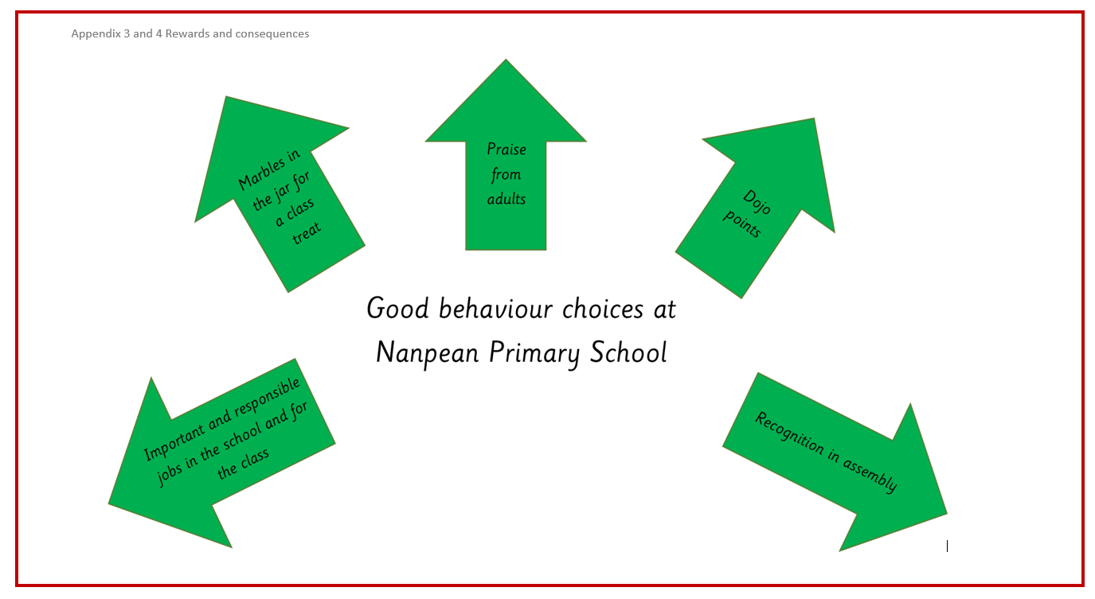

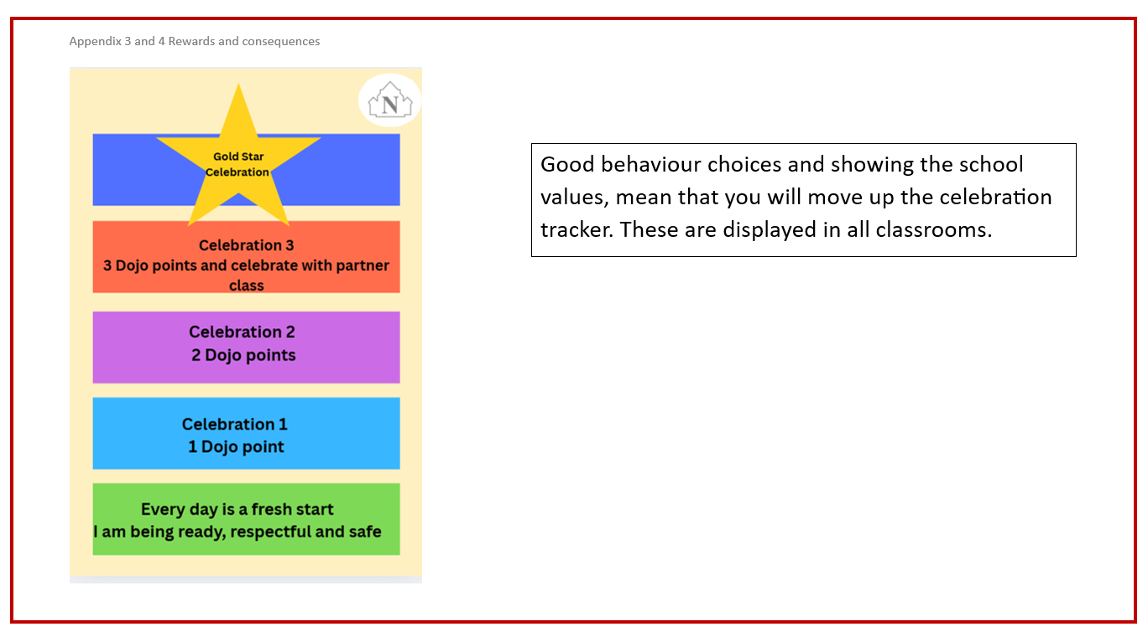

Appendix 3
Consequences
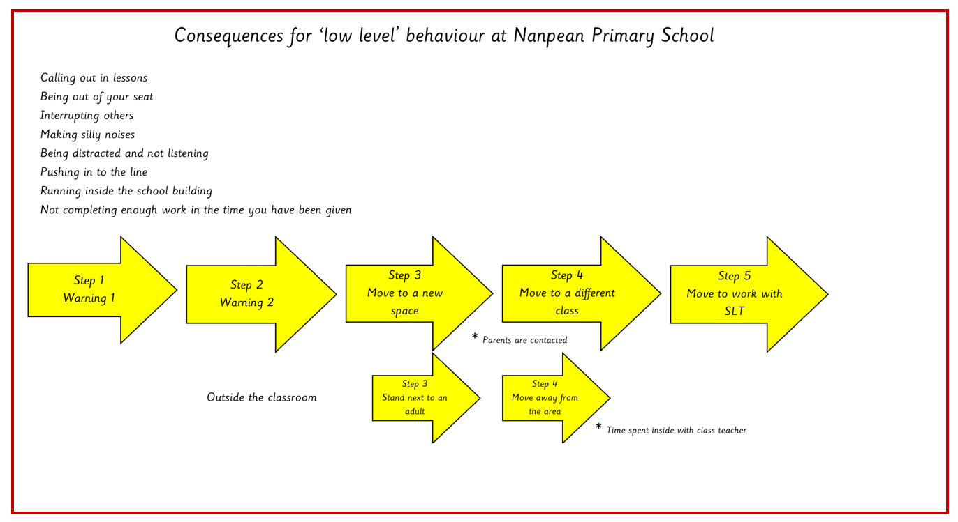

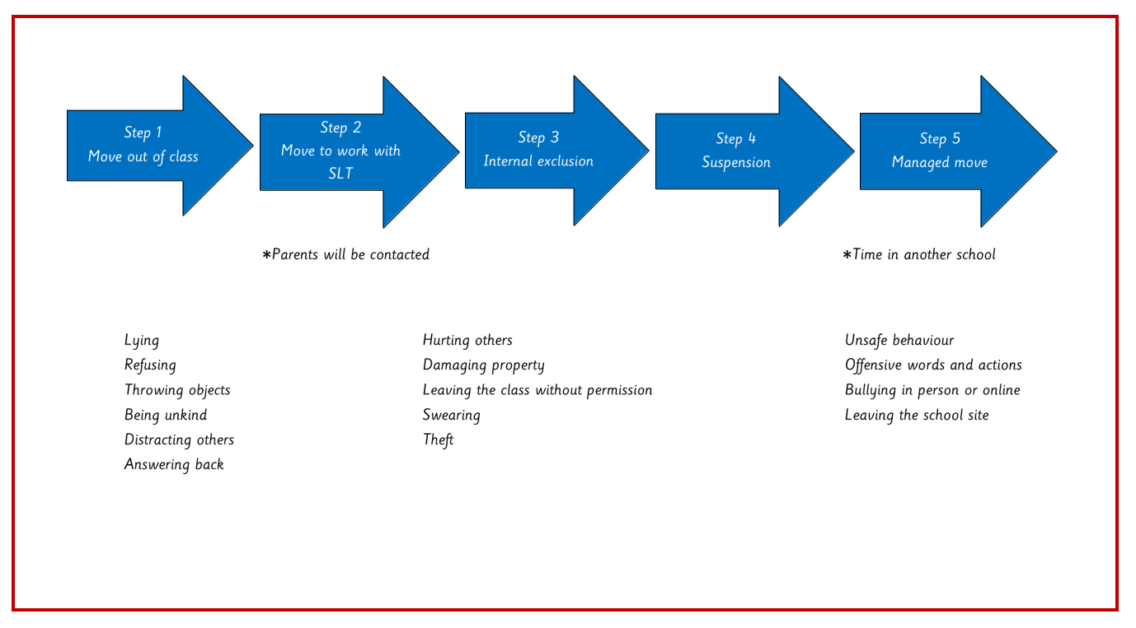

Questions to support restorative conversations:

