PE Funding

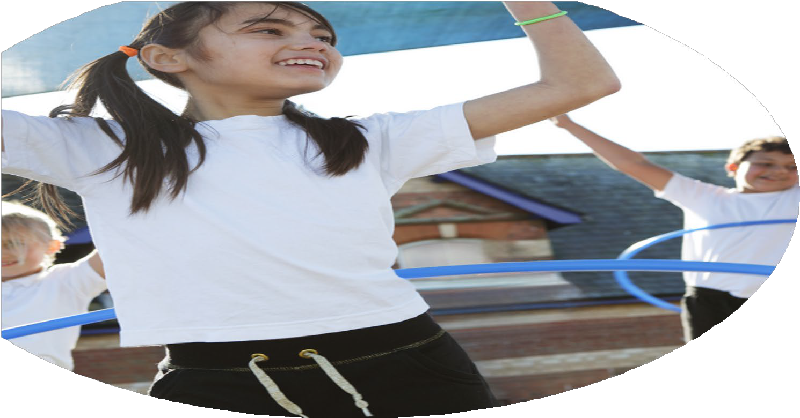

Evaluation Form

**Commissioned by**

**Created by**

Images courtesy of Youth Sport Trust

**PE Funding Evaluation Form**

 It is intended that this template should be used as preparation for the completion of the statutory digital reporting tool being introduced this academic year. You can upload data (including swimming) from this template onto this platform once it becomes accessible.

 Before you decide how you are going to use the funding for this academic year you should reflect and evaluate the impact of your use of the funding in 2023/24.

 All spending of the funding must conform with the terms outlined in the Conditions of Grant document.  The template is a working document that you can amend/update during the year.

 Based on your evaluation of last year’s funding you should decide what you intend to do this academic year, how you will do it, and what impact you expect it to have.

It is important that the funding is used effectively and based on your school’s needs.

 You must use the funding to make additional and sustainable improvements to the PE and sport in your school.  You must develop and add to the PESSPA activities that your school already offers.

*Summative digital reporting from June 2025 will continue to include swimming and water safety information therefore funding can be used to provide top-up lessons where necessary to ensure pupils meet national curriculum swimming requirements.*

**We recommend that you start by reflecting on the impact of current provision and reviewing your previous spend**

|  |  |  |  |
| --- | --- | --- | --- |
| What went well? | How do you know? | What didn’t go well? | How do you know? |
| Work closely with local secondary school to provide opportunities for competitive sport within the cluster for a variety of children  2 hours per day (10 hours per week) allocated to providing a range of sports and physical activity related after-school clubs.  2 hours per day (10 hours per week) allocated to organised lunchtime activity, led by adults (including ball games, dance, fitness activities and trim trail).  Specialist coaches employed termly to make links between the Wider Curriculum and Dance (Rob Mennear) | Increased participation in competitive sport  Increased participation in a range of clubs.  Increased participation in range of activities.  Increased confidence, knowledge, and skills of all staff in teaching PE and Sport. | Providing staff swimming CPD and Life Saving skills for children who have met end of KS swimming expectations as well as additional swimming | Expectations from leisure centre changed due to using swim teachers. |

|  |  |
| --- | --- |
| What are your plans for 2024/25? | How are you going to action and achieve these plans? |
| Intent | Implementation |
| *These plans have been revised due to change in leadership*  *Curriculum review i.e., what is it now? (staff confidence and engagement in teaching the PE curriculum). Create a curriculum that meets the needs of the pupils in our school. How do we want our current provision to change to suit the needs of our current cohorts?  *Clubs and sporting events to continue to be led by Sports Coach. SL to enquire about who to contact about this.    *SL to enquire about Play Leaders  *New Subject Lead to engage with TPAT support package | Discussions with staff and pupils  Pupil conference  Use this to decide upon how the curriculum will look  Subject Leader to research PE curriculum  Staff skills audit and conferencing.  Training for Y5 pupils  Breaktime activities led by leaders  Source CPD providers  Identify which activities/ elements of teaching staff need CPD.  Questioning, transitions, pupil progress etc |

|  |  |
| --- | --- |
| What impact/intended impact/sustainability are you  expecting? | How will you know? What **evidence** do you have or  expect to have? |
| *Curriculum  Improvements in quality of learning, quality of teaching, and confidence of staff.  Revised curriculum for PE  *Clubs and Inter School Events  Range of experiences for children improved more children attending and wanting to attend clubs and activities. More children thriving on the opportunities offered. (Sailing, inter school events.)  More activites on offer for younger pupils in KS1  Children to experience a range of events as part of the package offered by Secondary School  *Play Leaders  UKS2 children to develop confidence in organising and leading activities.  LKS2 children to access and engage in physical activity at lunchtime  *CPD  New to role SL to access support offered by Trust. | Learning walk, skills audits verbal comments from staff or pupils, fewer non-doers or children opting out.  Updated documents and pupil engagement improved  Increase in the number of pupils doing activities girls, boys, year groups, PP, SEND  Clubs offered each day after school. Lunch time club offered.  Increase in physical activity due to fewer break and lunchtime behaviour incidents as children encouraged to be involved in structured play.  Subject Leader to have an improved understanding of the expectations of the role. |

|  |  |
| --- | --- |
| What **impact/sustainability** have you seen? | What **evidence** do you have? |
| *Curriculum  Following strategic networking with other PE Leads within the Trust, leadership researched and trialled a range of PE curriculum models. A six-week trial of the REAL PE scheme was conducted by the PE Subject Lead (SL) and a KS2 colleague. Feedback from the trial was shared with SLT and teaching staff, leading to the adoption of a sustainable whole-school model:   * **KS1 & KS2**: One weekly REAL PE lesson and one activity-based lesson * **EYFS**: Two REAL PE lessons per week   This model ensures a balance between structured, skill-based progression and wider exposure to games-based learning.  Teachers using REAL PE report increased confidence, improved subject knowledge, and the ability to deliver more structured, high-quality lessons.  There is a noticeable increase in expectations for pupil progression in physical skills.  Staff now have a broader repertoire of games, challenges, and organisational strategies that engage pupils and develop physical literacy in a progressive and inclusive way.  Pupils are benefiting from a consistent, high-quality PE experience across year groups.  The mix of REAL PE and activity-based lessons gives pupils variety and allows them to build fundamental movement skills alongside the opportunity to apply them in games and activities that may be encountered in inter-school competitions.  Enjoyment and engagement levels in PE have increased, as noted in pupil voice.  The chosen curriculum model is embedded across EYFS, KS1, and KS2, ensuring long-term consistency and progression.  Teachers are continuing to build confidence and autonomy in using REAL PE.  Ongoing professional dialogue around REAL PE ensures a culture of reflective practice and shared expertise, further embedding sustainable, high-quality PE.  *Clubs and Inter School Events  The continuation of extracurricular sports and activity clubs have had a significant impact on pupil engagement and well-being. More children are now actively participating in a wider range of physical activities, both during and beyond the school day. Attendance at clubs has increased, with pupils demonstrating greater enthusiasm, commitment, and pride in representing the school.  This inclusive and varied offer has ensured that all pupils, regardless of ability, are able to access meaningful physical experiences. Sessions are accessible to a wide range of pupils, including those who may not typically engage in sport. By embedding this provision into our ongoing extracurricular offer, we are promoting long-term participation and enjoyment of physical activity. As a result, children are not only improving in physical fitness and skill development but also building vital life skills such as teamwork and resilience leadership. Pupils are thriving in environments where they feel challenged, supported, and motivated to succeed.  External sporting events, and leadership roles for older pupils has further enriched our provision, helping to foster a strong sense of community and sportsmanship with the aim of having a lasting impact on their personal development, confidence, and overall school experience.  *Play Leaders  Our Play Leader programme has empowered Upper Key Stage 2 (UKS2) children to develop confidence and leadership skills by organising and leading physical activities during lunchtimes. This not only nurtures their communication, teamwork, and responsibility but also creates positive role models within the school community.  Lower Key Stage 2 (LKS2) and KS1 children benefit from increased opportunities to access and engage in a variety of physical activities at lunchtime, contributing to improved fitness, social interaction, and enjoyment of active play.  Importantly, the programme respects individual pupil choice; children who do not wish to continue as Play Leaders are supported to step down without pressure, ensuring that participation remains voluntary and positive.  The sustainability of this initiative is secured through ongoing training and support for new cohorts of Play Leaders each year, embedded within the school’s wider PE and wellbeing provision. By developing pupil leadership capacity, we create a lasting culture of peer-led activity that enhances engagement and physical activity levels across the school.  *CPD  As part of our commitment to using the PE and Sport Premium funding effectively, the new Subject Lead (SL) has accessed tailored professional development and support provided by the Trust.  By building the SL’s capacity through ongoing training, the school ensures sustainable leadership of PE, enabling continual improvement in the quality and inclusivity of PE lessons and extracurricular activities. This approach maximises the impact of the Premium by embedding best practices and maintaining high standards across the school for years to come.  * School Sports Day  This year, we successfully revised the format of Sports Day to include a greater focus on inclusive participation, pupil enjoyment, and community engagement. A new structure was introduced that balanced competitive and non-competitive activities, ensuring all pupils could take part meaningfully. Parents and carers were invited to attend and share a picnic lunch with their children, creating a celebratory and community-focused atmosphere.  The format has now been adopted as the model for future Sports Days, with a clear structure that can be easily repeated and adapted.  Resources, timetables, and activity plans have been created and saved for use in future years.  Staff are confident in delivering this format, and parental engagement has increased, supporting long-term community involvement in school sport. | Teacher feedback from before and after the 6-week REAL PE trial, showing increased confidence and knowledge.  Teacher meeting minutes documenting discussion of REAL PE, feedback, and decision-making process.  Adopted PE timetable structure (e.g., 1 REAL PE + 1 activity-based lesson per week) across year groups.  Long-term and medium-term PE plans reflecting the blended approach and alignment with REAL PE fundamentals and inter-school games preparation.  Pupil voice surveys showing positive feedback about PE variety, challenge, and enjoyment.  Photographs or video evidence of pupils engaging in varied lessons and challenges.  Teachers and pupils have expressed that watching the clips of the skills explored the the lesson prior to leaving the classroom not only assists with correct modeling but really motivates and excites the children about their PE lesson-they are inspired to be like the children demonstrating on the video clip.  Club registers showing increased attendance across a range of activities , including pupil premium and SEND.  Pupil surveys reflect a continued interest in sports and active clubs.  Newsletters highlighting the diverse range of clubs.  Pupil voice feedback noting increased enjoyment and accessibility of activities.  Photos or videos showcasing events and after-school clubs.  Inclusion of less active pupils or vulnerable groups (e.g., SEND, PP) in tailored clubs.  Case studies of individual pupils showing improvements in confidence or behaviour through PE engagement.  Evidence of pupil leadership in sport (e.g., sports captains, play leaders helping run sessions).  Teacher comments in end of year reports, noting strengths in teamwork, and communication.  Comments from UKS2 Play Leaders reflecting increased confidence, communication, and leadership skills.  Feedback from LKS2 pupils on their enjoyment and engagement during Lunchtime activities led by Play Leaders.  Observations by staff and PE Lead noting the quality of Play Leader-led activities and pupil engagement.  Behaviour and wellbeing observations showing positive impact of structured playtime activities for the Play Leaders and participants.  Future action plans will outline the ongoing training and recruitment of Play Leaders.  Evidence of Play Leader roles being embedded in school policies and other relevant documents.  Invites and session agendas for training events attended by the SL.  Copies of PE development action plans  Documentation showing changes made to the PE curriculum or extracurricular provision as a result of CPD learning.  Reports from meetings where the SL presents progress on PE improvements.  Pupil voice indicated increased enjoyment and motivation, with many pupils citing the day as a highlight of the school year. Pupils discuss photos on display in corridor.  Parent feedback was overwhelmingly positive, noting the inclusive and family-friendly nature of the event.  All pupils were actively engaged in a variety of physical challenges, supporting key PE outcomes around fitness, resilience, and teamwork.  The event supported whole-school wellbeing priorities and strengthened relationships between school and families. |