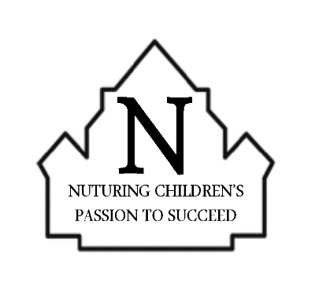

Job Advertisement for Year R (EYFS) Fixed Term until July 2022 (to begin in January 2022).

Details  Pay Grade: Grade D  Contract Type: Temporary (January – July 2022)  Hours per week: 17.5  Deadline for Applications: 12noon on Monday 29th November, 2021  Interview Date: TBC | Nanpean CP School,  St George’s Road,  Nanpean,  St Austell,  Cornwall.  PL26 7YH.  Tel: 01726 822447  www.nanpean.cornwall.sch.uk  E-mail: office@nanpean.cornwall.sch.uk | How to apply  Download and complete the application form and equal opportunities monitoring form, then send these to office@nanpean.cornwall.sch.uk by 12noon on Monday 29th November, 2021  Interview Date: TBC

Nanpean School is looking to appoint a dedicated, enthusiastic and adaptable Teaching Assistant to work initially in Year R (EYFS) and carry out lunchtime supervision for 17.5 hours per week (8.45 – 11.45am and a portion of lunchtime) each day of the school week (Monday – Friday). However, this will constantly be under review and all staff members can be re-deployed to adapt to the changing needs of the school. The post will commence in the Spring Term on Wednesday 5th January, 2022.
This person needs to be able to challenge and encourage young minds, and become a valuable contributor to an outgoing and committed team. A sense of humour is key, coupled with a genuine commitment and determination to ensure our pupils receive the best learning opportunities and make accelerated progress.
We are committed to safeguarding children and the successful candidate will be required to undertake an enhanced DBS check.
If selected for Interview, this will include being observed leading a session with a group of children as well as a formal interview.

The successful candidate will be:
- Passionate about a child-centred approach to education
- Able to motivate and challenge young learners
- Able to demonstrate high expectations and aspirations for all
- Able to build positive relationships with pupils, parents, governors and our community
- A strong team player with good communication and interpersonal skills
- Flexible and adaptable

In return, we can offer you:
- A supportive and enjoyable working environment with a SLT committed to supporting staff wellbeing
- A commitment to your own professional development, and the continued development of the school
- Wonderful children who are enthusiastic and eager to learn and please
- Supportive staff, parents and Governors
- A well-resourced and maintained school

